**Long-Term Effects of Dam Removal on Sediment Dynamics: Insights from Edgewood’s Atkisson Dam**

Gabriel Guzman, Dan Soloway, Zoe Bremmer

Department of Environmental Studies, Gettysburg College

Dr. Tasha Gownaris

April 18th, 2024

*Keywords*

*Submerged Aquatic Vegetation, Sediment Loading, Nutrient Loading, NERRS, APG, Chesapeake Bay, Otter Point Creek, Estuary, Secchi, PACF, CCF, Landsat, Dam removal*

**Abstract**

Submerged aquatic vegetation (SAV) plays a critical role in freshwater ecosystems by providing habitat and food for fish and other aquatic organisms, improving water quality, and sequestering carbon. However, this vegetation can be highly sensitive to changes in its environment, including to nutrient and sediment loads. Here, we study the impacts of upstream dam removal (Atkisson Dam) on SAV abundance and survival in the National Estuarine Research Reserve of Otter Point Creek (OPC) and Atkisson Dam, located in the Chesapeake Bay, Maryland.

By tying historical SAV cover data to changes in suspended sediment concentration (SSC) and nutrient loading using data collected by the National Estuarine Research Reserve, our research aims to provide a new perspective on proposed dam removal plans. Additionally, we used Google Earth Engine to collect Landsat imagery of both the OPC and Atkisson sites. Using water reflectance-based techniques, we detected substantial sediment accumulation upstream of Atkisson Dam, indicating the expansion of mudflat areas over time. We also collected sediment samples upstream of the dam, which suggested nutrient imbalances in the sediments that would likely have a negative impact on SAVs downstream if released. Based on our findings, we suggest that the Army Corps of Engineers Aberdeen Proving Ground team move forward with Course of Action 3, as it is the most conscious of the estuary’s needs. This Course of Action would result in only partial removal of the dam, however, so it will still impede fish migration. Therefore, the immediate focus should be on reducing sedimentation, and future mitigation strategies should be centered on fish passage and habitat restoration by removing the remnants of the dams.

**Introduction**

In North America alone, 57 freshwater fish taxa went extinct from the years 1898 to 2006 (Burkhead, 2012), making the extinction rate of North American freshwater fish 877 times the background extinction rate on Earth (Burkhead, 2012). Similarly, aquatic vegetation has seen an accelerated loss in coverage. Aquatic vegetation decreased by approximately 13.5-16.9% from 1900 to 1980; the rate of decrease went up to 33.6-59.8% from 2000-2017 (Zhang et al., 2017). This loss in aquatic vegetation can be attributed to human disturbance of nutrient balances in aquatic ecosystems (Yu et al., 2019). The reduction of biomass of aquatic vegetation leads to declining biodiversity, which in the case of some aquatic plant species leads to multi-trophic disturbances (Isbell et al., 2011).

Submerged aquatic vegetation (SAVs) are rooted aquatic plants that grow completely submerged underwater (NOAA, 2020). SAVs are crucial species for the well-being of freshwater ecosystems. SAVs provide habitat and improve foraging opportunities for fish. For example, fish consume larger prey in SAV areas as compared to unvegetated areas, and consequently have higher growth rates, lower mortality, and higher fecundity (Rozas & Odum, 1988). SAV meadows support a complex estuarine food web where a single acre of SAVs can support up to 40,000 fishes and 50 million small invertebrates (Miththapala, 2008).

Measuring Aquatic Ecosystem Health

Suspended sediment concentration (SSC) is among the most important factors in determining the anthropogenic effects on natural freshwater environments (Parsons, Cooper, & Wainwright, 2015). Excessive sedimentation can reduce habitat quality and carry pollutants such as heavy metals and pesticides, known to negatively impact aquatic vegetation (Afshan et al., 2014). In some instances, these pollutants affect higher trophic levels due to bioaccumulation (Ali & Khan, 2018). One of the most important factors of SAV health is turbidity, which is an index for light scattering by suspended particles (Davies-Colley & Smith, 2001). SSC coupled with other things like chlorophyll-a as phytoplankton can cause systems to become turbid. When there is an increase in chlorophyll-a, there is a reduction in light availability and the SAVs struggle to grow and face higher levels of competition since there is a limited amount of light available (Shields, Moore, & Parrish, 2011).

Another important factor in freshwater ecosystems is nutrient loading, as this metric is particularly important in understanding the health of aquatic vegetation, which tend to thrive within fairly small ranges of nutrient levels (Vanni et al., 2006). Excessive nutrient loading can lead to eutrophication and hypoxia, negatively impacting habitat quality for all species (Fernald, Yozzo, & Andreyko, 2009). Fully understanding nutrient dynamics in freshwater systems is necessary to prevent ecological imbalances. SSC can be altered by elevated streamflow, affecting water clarity (Ellison, Kiesling, & Fallon, 2009). Increased SSC levels are linked to affecting the ability of SAVs to become established in freshwater systems (Chilton et al., 2021).

Dam Removals and Impacts

Dam removal has been shown to increase the suspended sediment load concentration of freshwater systems significantly, which is linked to net negative effects on the health of ecological communities in freshwater systems (Bednarek, 2001). The removal of dams can have significant impacts on submerged aquatic vegetation, with changes in water level and sediment erosion leading to shifts in wetland communities (Lisius et al., 2018). Long-term winter flooding in dam drawdown areas can lead to a reduction in plant richness and changes in life form composition (Wang et al., 2012). The removal of dams can have significant impacts on estuarine ecosystems, particularly in terms of sedimentation. Dam removals can lead to net sediment deposition downstream, while the overall effects on channel adjustment are minor (Cheng & Granata, 2007). Foley (2015) and Foley (2017) observed rapid and large-scale changes in estuary conditions, including increased sedimentation, following the removal of the Elwha and Glines Canyon dams. These changes altered the structure and functioning of the Elwha River estuary ecosystem, leading to a reduction in the abundance of macroinvertebrates and fish.

This Study

Here, we aim to use the above important factors and relationships between them and SAV abundance to predict the impacts of upstream dam removal on a biologically important National Estuarine Research Reserve (NERR). Otter Point Creek (OPC), located north of the Chesapeake Bay, Maryland, is a 704-acre reserve made up of 93 acres of parkland with trails, 350 acres of forest land, and 261 acres of water (OPC.org, 2024). It was established in 1985 and is regularly monitored for water quality, habitat protection, and climate change effects (OPC.org, 2024). The Attkisson Dam is roughly seven miles north of OPC. There are plans for the U.S. Army Garrison Aberdeen Proving Ground (APG) to remove this dam and a smaller dam, located roughly one and a half miles north of OPC (Van Bibber Weir), sometime over the next several years. However, the impacts of dam removal on the SAV at OPC have not been considered. The Chesapeake Bay has a 14:1 ratio of land to water, which is the largest for any coastal water body in the world, so it is incredibly sensitive to anthropogenic activities (Zhang et al., 2023). The majority of land usage around the dams and Winter’s Run is primarily agricultural, which could impact nutrient loading downstream. With such a sensitive extension to the Otter Point Creek ecosystem, the entire bay could feel the changes that OPC feels from these dam removals and so precarity is the highest recommendation with the removals.

Hydrilla (*Hydrilla verticillata*) has an important role in protecting biodiversity in freshwater systems. While hydrilla can out-compete other SAV species, they have grabbed a foothold in this estuary and are integral to the survival of other aquatic life (UF IFAS, 2024). In an estuarine system, *Hydrilla* and other SAV species work together to produce a structural matrix on which many other species depend, improve water quality, and stabilize sediments (Fonseca et al., 1998). In the OPC system, chlorophyll-a is the main phytoplankton that is measured at the continuous monitoring station as the defining factor of the level of turbidity of the water.

Our research aims to address how the removal of Atkisson Dam will impact submerged aquatic vegetation at Otter Point Creek. With that, we have five interconnected sub-questions:

(*i)* What has been the historical range of nutrient conditions at OPC?, (*ii*) what is the natural historical variability in SAV cover at OPC and is this variability linked to water quality data?, (*iii*) what is the composition of the sediment behind and below the Atkisson Dam?, (*iv*) what is the water quality behind and below the Atkisson Dam?, (*v*) do the dam removals have the potential to create new mudflats at OPC?

By linking historical water quality and nutrient data with historical SAV abundance data, we can provide insight into the impacts of increased sediment loads. Additionally, we aim to better understand the composition of the sediment with nutrient test kits. Furthermore, we want to estimate the likelihood of further mudflat creation caused by the upstream removal of Atkisson Dam and to project the effect this sediment volume would have on SAVs if it were to be added to the OPC system. This research has the potential to inform conservation strategies and the management of OPC.

**Methods**

To address all of our research questions, we employed a multifaceted approach by using a multitude of tools. We used a Python nutrient and water quality analysis to address Q1, Q2, and Q4, MySoil test kits and combustion analysis to address Q3, and Earth Engine and QGIS to address Q5. By utilizing multiple tools, we can get a holistic view of the effects that will be caused downstream by the upstream dam removals.

Sediment Composition

*Fieldwork*

For our fieldwork component of this research project, we used 8 test kits from MySoil, a nutrient and pH testing company for soil and sediments, to test for nutrient levels within the sediments at each dam location. MySoil kits are research-grade nutrient test kits used for soil and sediment testing of 13 different nutrients and the pH level to recommend fertilizers for growing plants or grass, but we will be using the kits solely for the nutrient analysis. We sampled at two locations above the Atkisson Dam, one location below the Atkisson Dam, two locations above the Van Bibber Weir Dam, one location below the Van Bibber Weir Dam, and one location on the East bank of Otter Point Creek (Figure 1.3). During our data collection, we were unable to collect data at two locations, one below the Atkisson Dam and one below the Van Bibber Weir Dam, because the bed of the river was completely rocky. Our sampling process included using a corer with a width of 1.5 inches to gather sediments ~6 inches deep and then using a scooper to gather the sediments from the deepest depth of the coring device. After collection, we sent samples to MySoil for analysis.

*Combustion Analysis*

At each site of coring, we also collected separate jars of sediments to complete a combustion analysis. A combustion analysis was conducted to determine the loss on ignition of organic material in the sediments (Dean, 1974). Eight crucibles filled with sediments from each site were heated at 100ºC for 24 hours, then heated again at 550ºC for another 24 hours. Crucible weight with and without sample was taken and weight was taken after each heating.

Mudflat Creation

Surface reflectance, which refers to the amount of light reflected by the Earth's surface, is closely related to sediment buildup in surface water (Figure 1.2). Sediment buildup, caused primarily by soil erosion, is a significant contributor to non-point source pollution. When soil particles are carried away from the land surface and deposited into surface water bodies, they degrade water quality. Additionally, contaminants such as nutrients and pesticides often attach to these soil particles, further compromising water quality. To find visual evidence of the effects of sediment buildup over time, we used Landsat Imagery available from Google Earth. The Landsat Imagery was recorded at Atkisson Dam and Otter Point Creek in 2003 and 2023. These images were then converted into a two-period change analysis with a before period (2003-03-14 & 2009-06-01) and an after period (2010-03-14 & 2023-06-01) with both True Color and False Color images of both sites included within the Google Earth Engine script. When Landsat imagery is used to create true color images, a composite is formed by combining the intensities of red, green, and blue (RGB) light to produce an image that appears to contain the same colors as those seen by the naked eye. False color composites allow us to see wavelengths beyond the human eye, such as near-infrared bands. This increases spectral separation, improving data interpretability. From the two-period change analysis with True Color imaging, an increase in mudflat area is noticeable, as seen in (Figure 1). Additionally, when reviewing the False Color images of both sites, mudflat and sediment area increases can also be noticed (Figure 2).

Nutrient and Water Quality Analysis

*Nutrient correlation*

Nutrient data was collected from the NERR continuous monitoring station at the Otter Point Creek site. This data was collected daily from 2003 - 2023 and provided by the NERR online query system.

To understand any differences in the rate of dissolution of orthophosphate (PO4F), ammonium (NH4F), nitrite (NO2F), and nitrate (NO3F) in OPC, we performed a Pearson correlation coefficient analysis. This analysis illustrates the relationships between the concentrations of all nutrients compared to one another. This Pearson correlation coefficient analysis was performed in Python using nutrient data collected from the NERRs continuous monitoring station at OPC from 2003 to 2022 (cbmocnut.csv). The packages *pandas*, *matplotlib,* and *seaborn* were used for this analysis.

*Effects of Secchi on SAVs*

Secchi is an important factor in the determination of SAV health at the Otter Point Creek site. Seeking to quantify the effect of chlorophyll-a on SAV growth over time (in volume), we performed a partial autocorrelation function analysis (PACF) to determine the lag time where SAV and Secchi are most correlated. A Pearson correlation regression for SAV and Secchi was performed, which was then inputted into a cross-correlation function analysis (CCF), as well as the PACF values derived from the initial statistical test. Figures for the PACF, Pearson correlation analysis, and cross-correlation analysis were generated. These statistics and figures were generated with the aid of the *pandas*, *matplotlib*, *numpy*, *seaborn,* and *statsmodels* modules on Python. *Pandas, matplotlib,* and *numpy* were used for data parsing, basic figure generation, and loading data into functions. *Seaborn* was used for Pearson correlation visualizations, while *stastmodels* was used for cross-correlation function and partial-autocorrelation function models.

*Effects of Chlorophyll-A on SAV*

Additionally, we conducted a PACF analysis followed by a correlation analysis. to determine the temporal range at which intra-variable correlation peaks. A Pearson correlation analysis was performed, as to create a CCF model in conjunction with the peak correlation time lag value derived from PACF analysis. Python and its *pandas*, *matplotlib*, *numpy*, *seaborn,* and *statsmodels* modules were essential in performing these statistics.

*Effects of Dissolved Nutrients on SAVs*

With the aim of better understanding how dissolved nutrients affect SAV growth, measured in volume, a linear regression comparing the relationship between nutrient concentration and SAV growth. A Pearson correlation analysis was performed to quantitatively determine the relationship between nutrient concentrations and SAV growth. Python and its *pandas*, *matplotlib,* and *seaborn* modules were essential in performing these statistics.

**Results**

Sediment Composition

*MySoil Nutrient Analysis*

We compared the recommended ranges for pH, dissolved nutrients, and metals for submerged aquatic vegetation determined by the Environmental Protection Agency (EPA, 2021). We created a series of bar graphs to denote the relative concentration between sites. Additionally, we included ‘optimal range’ bars to indicate the desired concentrations as per EPA standards. Ammonium, iron, and manganese levels exceeded the ideal range for SAV growth, which could potentially inhibit SAV development. On the other hand, boron, calcium, magnesium, phosphorus, and potassium were within the recommended ranges. However, copper, nitrogen, pH, and zinc fell below the EPA recommendations. The inconsistent results for sulfur across different sites further emphasize the complex nature of soil nutrient dynamics and their potential implications for SAVs (Table 1.1).

*Combustion Analysis*

After completion of the combustion analysis, we found that at both sites above Atkisson Dam were very high in organic material (Table 2.1). Percentage of organic material was high at sites AD 1 (24.94%), AD 2 (23.89%), AD 4 (8.03%), and VB 2 (7.70%).

Mudflat Creation

From the two-period change analysis with True Color imaging, we found an increase in mudflat area (Figure 1.1). When comparing the mudflats, indicated by browner areas within the water of Otter Point Creek in 2003, there is a significant increase in this area by 2023. Additionally, when reviewing the False Color images of both sites, mudflat area increases can also be noticed (Figure 1.3). For the Atkisson site, reflectance of the site changed, showing a loss of water area and an increased reflectance area of land/vegetation, as depicted by the red. This is also indicating the shape of the river had changed. More specifically, there was a large loss of water area within the river when comparing the False Color images of 2003 to 2023.

Nutrient and Water Quality Analysis

*Nutrient vs nutrient correlation*

The rate of dissolution of orthophosphate (PO4F), ammonium (NH4F), nitrite (NO2F), and nitrate (NO3F), which can be found in Figure 2.1, were not significantly different from one another. SAV growth was found to have a slightly positive correlation for nitrate (NO3F) and nitrites (NO2F) while having no significant correlation to ammonium (NH4F) and orthophosphate (PO4F). Statistics for significance were not performed for this analysis, however, correlation results still provide important insights into our study area.

*Effects of Secchi on SAVs*

The cross-correlation function (Figure 3.2) performed between Sechhi and SAV volume in all sites surveyed revealed a slight positive relation when adjusted for the lag period (0 weeks as per the partial autocorrelation function) determined using a partial autocorrelation function (Figure 3.1).

*Effects of Chlorophyll-A on SAV*

The cross-correlation function (Figure 4.2) performed between Chlorophyll-A concentration and SAV volume in all sites surveyed revealed a positive relation when adjusted for the lag period determined using a partial autocorrelation function (Figure 4.1). The correlation between various points over time for chlorophyll-a and SAV volume are portrayed in the y-axis. The y-axis portrays the amount of points over time. This cross-correlation function showed slightly positive results.

*Effects of Dissolved Nutrients on SAVs*

Nitrate and nitrite were found to negatively affect the growth of SAVs with statistical significance (Figure 5.1). Nitrate and nitrate concentrations were portrayed in the x-axis while the values for SAV volume were portrayed in the y-axis.

**Discussion**

In the MySoil Experiment, several soil nutrients were measured against EPA-recommended concentration ranges. All sampling sites far exceeded the EPA recommended ranges for ammonium and phosphorus, positing that there could be a large influx into the estuary of the two biggest nutrients that cause eutrophication and hypoxia (Table 1.1). Excessive nutrients, particularly phosphorus, can lead to eutrophication and have complex effects on submerged aquatic vegetation (Barko, 1998). High nutrient concentrations can also lead to a catastrophic loss of submerged aquatic plants, particularly due to shading and anoxia caused by dense mats of floating plants (Morris, 2003). Additionally, all sites were severely lacking in calcium, which is an important nutrient for SAV growth and sediments that enter the estuary that lack such an important nutrient could lead to SAV abundance decline if they do not have a proportionate amount of a necessary nutrient (Ali & Soltan, 1996).

The percentage of organic material in estuarine sediments varies widely, with studies reporting ranges from 0.04% to 3.70% in the Bohai Sea (Run, 2015) and 3.5% to nearly 4% in Choctawhatchee Bay, Florida (Palacas, 1967). These variations are influenced by factors such as the hydrodynamic conditions of the estuary (Vilhena, 2017) and the mineralogy of the sediments (Berryhill, 1972). From our combustion analysis, we found percentages of organic material in the sediments above the dams that exceed these varied ranges multiple times over (Table 2.1). If the sediments were to flow down the river, unimpeded post-dam removal, this would result in an excess of organic material in the estuary, which could result in eutrophication if the dam sediments add too much organic material to the estuary system.

In Otter Point Creek, there was a marked expansion of mudflats from 2003 to 2023, visible particularly in the browner areas of True Color images and the increased red reflectance in False Color images. This change suggests sediment accumulation, altering the river's shape and affecting its reflectance characteristics. Concurrently, the Atkisson site presents a noticeable loss in the water area and an increase in land/vegetation reflectance, suggesting similar sediment deposition and river morphology alterations.

Moving to nutrient correlations, the rates of dissolution for orthophosphate (PO4F), ammonium (NH4F), nitrite (NO2F), and nitrate (NO3F) showed little correlation amongst one another (Table 1). Nitrate and nitrite were found to harm SAV growth with statistical significance, highlighting the potential adverse effects of these nutrients on aquatic ecosystems. Adverse effects on the estuary could be algal blooms and hypoxia. Excess nutrient loading in estuarine ecosystems has been long studied and has been documented to have negative effects on the survival of SAVs (Nedwell et al., 1999), and with this dam removal, the sediments will carry high levels of iron and nitrogen, which could lead to excessive nutrient loading in OPC (Figures 6.5 and 6.9).

Our investigation of the effects of Secchi and chlorophyll-a in OPC revealed that there is a biological lag between changes in these environmental variables and changes in SAV volume (Figures 3.1 and 4.1). The cross-correlation function analysis for chlorophyll-a and its effects on SAV volume (Figure 4.2) revealed a positive correlation when adjusted for biological lags, suggesting that an increase in chlorophyll-a increases SAV volume over time, which was not expected as we hypothesized that an increase in chlorophyll-a would lead to a reduction of SAV. Show Dam removal is expected to lead to an increase in nutrient dissolution, which could lead to an increase in the chlorophyll-a concentration in the OPC system, which based on these experimental results may lead to an increase of SAV at OPC. Dam removal will lead to an increase in the Secchi, this analysis suggests that an increase in Secchi followed by the dam removal will lead to no change in SAV volume downstream.

Moving Forward

This research has highlighted the potential ecological repercussions of upstream dam removals on SAV abundance, water quality, and sediment dynamics. Utilizing advanced GIS techniques, we've observed significant sediment buildup and changes in water reflectance, suggesting an increase in mudflat areas over time. Additionally, our nutrient correlation analyses revealed that nitrate and nitrite negatively impact SAV growth, emphasizing the critical balance of nutrients for aquatic vegetation health and the precarity required in these dam removal situations to avoid excess nutrients and possible algal blooms (Palinkas et al., 2019). The OPC system, writ-large the Chesapeake Bay system, is a very important stop-over for migratory birds looking to feed on emergent vegetation or fish, and for fish seeking refuge in the SAV meadows. Algal blooms in a subset of the Chesapeake system will have effects on the entire system which in turn, affects the habitats for the birds by killing important emergent vegetation and macroinvertebrates (Rattener et al., 2022). Protecting the Chesapeake from nutrient overloading will keep the habitats for the birds safe for use during their stop-overs and it will continue to be a wonderful spot for bird-watching for those who enjoy.

The MySoil experiment further substantiates concerns about nutrient imbalances in sediment composition, with several nutrients exceeding EPA-recommended levels, potentially inhibiting SAV development. Conversely, some essential nutrients for SAVs are below the optimal range, indicating that not all the nutrients carried by the sediments are going to help SAV growth. Given these findings, the removal of the Atkisson Dam could exacerbate existing challenges, such as increased sediment load, nutrient overload, and potential mudflat extension, all of which could further degrade SAV habitats and overall water quality. Therefore, a holistic approach to conservation and management strategies is imperative to mitigate the adverse effects of dam removal and ensure the preservation of these invaluable freshwater ecosystems. Implementing monitoring and management plans based on suspended sediment concentration and sediment and nutrient loading, and leveraging advanced GIS and nutrient correlation analyses will be crucial steps toward informed decision-making and effective conservation efforts for the protection of SAVs and associated wildlife in the OPC and Atkisson Dam areas. Further collection of SAV abundance data by the NERRs team is recommended as the historical data was very well done and continuing this program allows for continued exact data on the abundance of all documented SAV species in the estuary and can be used to ensure that any detrimental impacts are monitored.

In the draft Environmental Assessment written and submitted by the APG, there were a few possible proposed actions listed for dam removal and with a pointed note of precarity required, the most careful removal action is what should be chosen, specifically course of action (COA) 3. COA 3 entails draining the reservoir incrementally by systematically removing portions of the dam, maximizing sediment retention and stabilization, and removing the majority of Atkisson Dam and Van Bibber Weir (O’Sullivan et al., 2022). This alternative would allow for a more gradual release of sediments and possibly the least amount of sedimentation into the OPC system, which would help to reduce the amount of increase of the mudflat area at the mouth of Winter’s Run. Although this alternative would be a complete reflection of direct mitigation of the focus of this project’s goals, there will still be negative effects on the entire ecosystem as the partial removal of the dams will not fully remove the barriers in fish passage during migration which presents problems for the greater Chesapeake Bay as an increase in fish abundance would positively impact the biodiversity and ecosystem of the Bay (Huang et al., 2023). The final recommendations would be to focus on reducing the sedimentation impact of the dam removals, and then look at the mitigation strategies to help fish passage and habitat restoration for fish abundance as spawning sites have higher use when dams are completely removed (Ogburn et al., 2021).

Moving forward, we recommend to NERRs and APG to advocate for the slowest and most conscious removal process possible, so that the health of the estuary can be a top priority in the dam removal. Further monitoring of SAV abundance in the OPC system is necessary as well to continue to monitor the effects downstream from the upstream removals. Continued monitoring of SAV abundance coupled with continuous monitoring of water quality and nutrient concentrations in the water will help to gauge the actual effects of the dam removals on the SAVs. This study hopes to help the NERRs team understand what preliminary testing has shown for nutrient concentrations in the sediments, but further and more in-depth studies should follow this one. Our study is limited by human error, time constraints, and limited resources to what students funds can buy. With the backing of the state for funding, we hope that NERRs can pick up from where we left on and continue to monitor any changes from the dam removals.

**Figures**

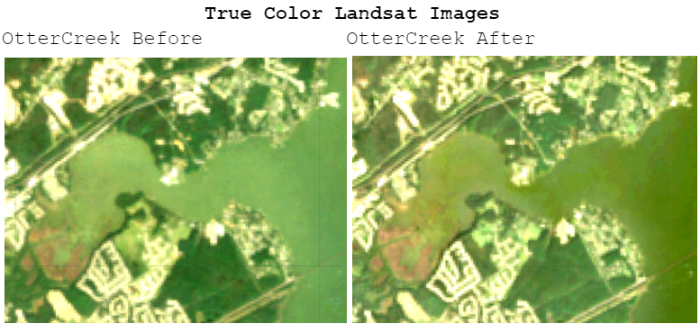

**Figure 1:** True Color Landsat images showing the growth of the mudflat at the mouth of Winter’s Run from 2003 to 2023, shown in the bottom left corner in brown.

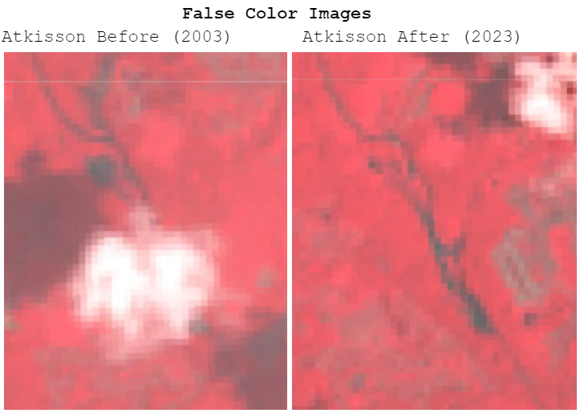

**Figure 2:** False Color Landsat images further highlight the change in water loss to sedimentation.

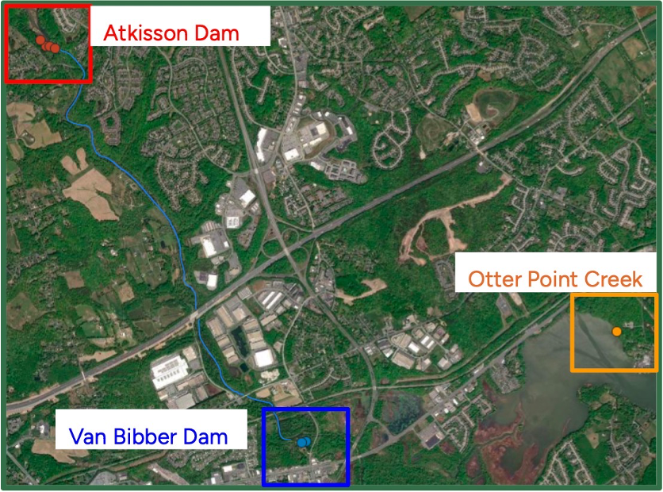

**Figure 3:** Map of coring and sediment collection locations at Van Bibber Dam, Atkinson Dam, and Otter Point Creek.

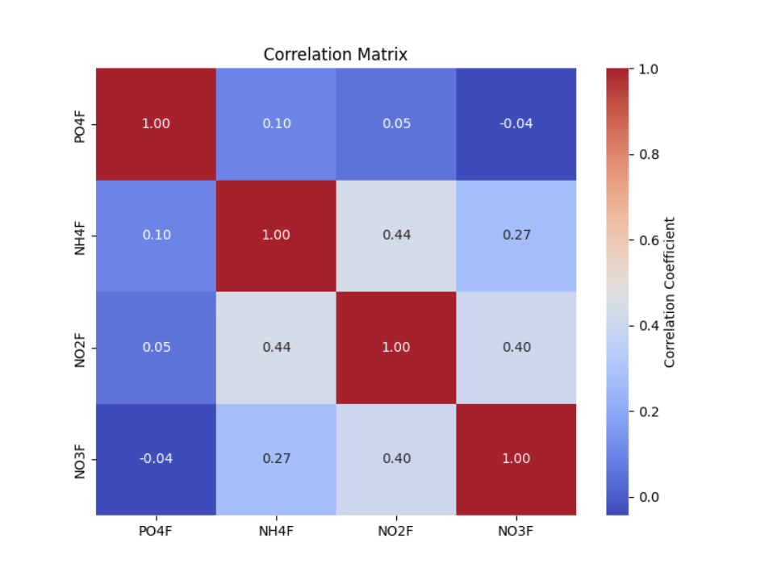

**Figure 2.1:** Pearson correlation coefficient matrix for orthophosphate (PO4F), ammonium (NH4F), nitrite (NO2F) and nitrate (NO3F). Daily continuous monitoring station nutrient data (2003- 2023) was provided by the National Estuarine Research Reserve (NERR).

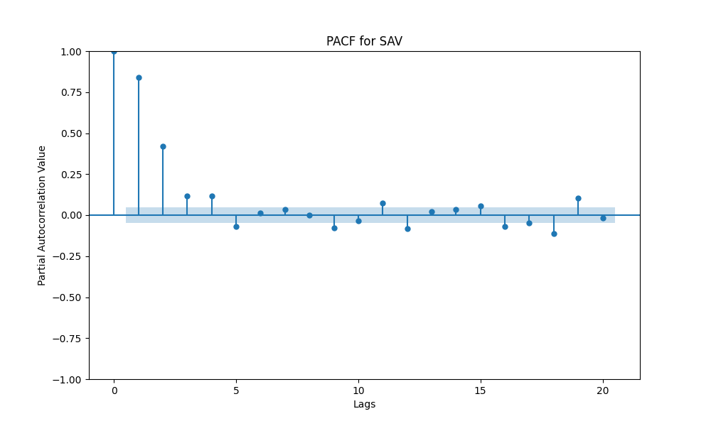

**Figure 3.1:** Partial autocorrelation function for Secchi concentration vs SAV volume in Otter Point Creek. The Y-axis portrays whether the correlation is positive or negative and the X-axis shows the lag (in weeks).

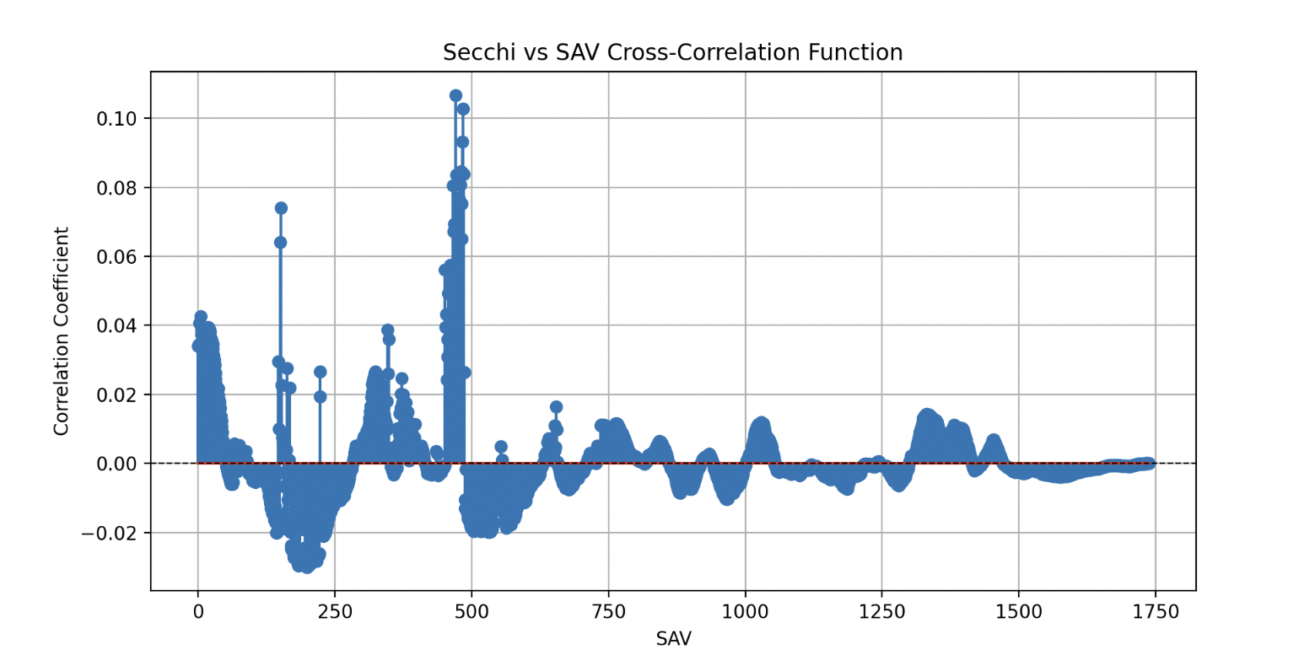

**Figure 3.2:** Time-lag adjusted cross-correlation function (CCF) for Secchi vs SAV volume in Otter Point Creek. The Y-axis portrays whether the correlation is Secchi vs SAV is positive or negative and the X-axis shows the compared data points over time.

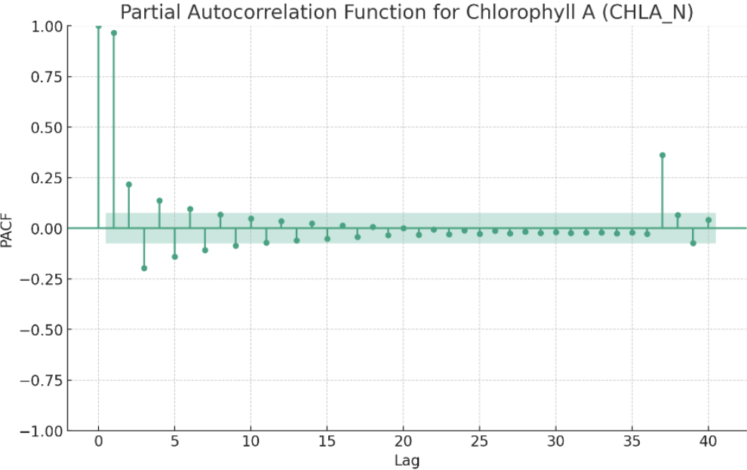

**Figure 4.1:** Partial autocorrelation function for Chlorophyll-A concentration vs SAV volume in Otter Point Creek. The Y-axis portrays whether the correlation is positive or negative and the X-axis shows the lag (in weeks).

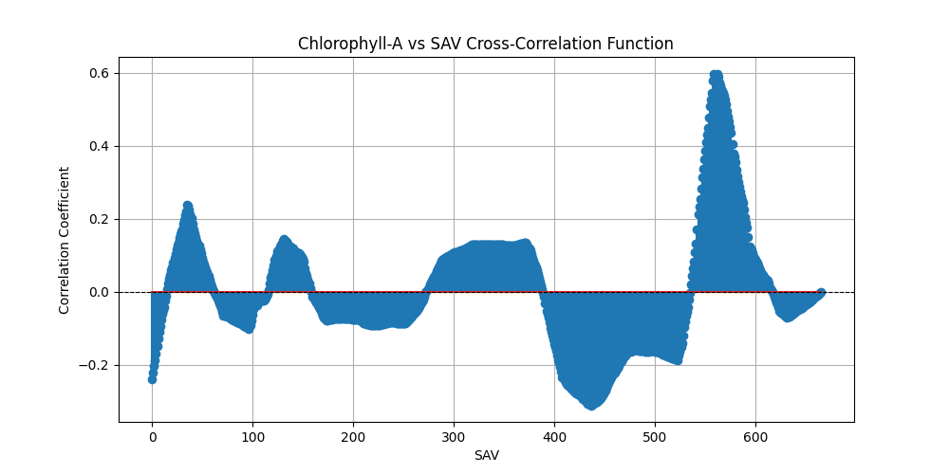

**Figure 4.2:** Time-lag adjusted cross-correlation function (CCF) for Chlorophyll-A vs SAV volume in Otter Point Creek. The Y-axis portrays whether the correlation is Secchi vs SAV is positive or negative and the X-axis shows the compared data points over time.

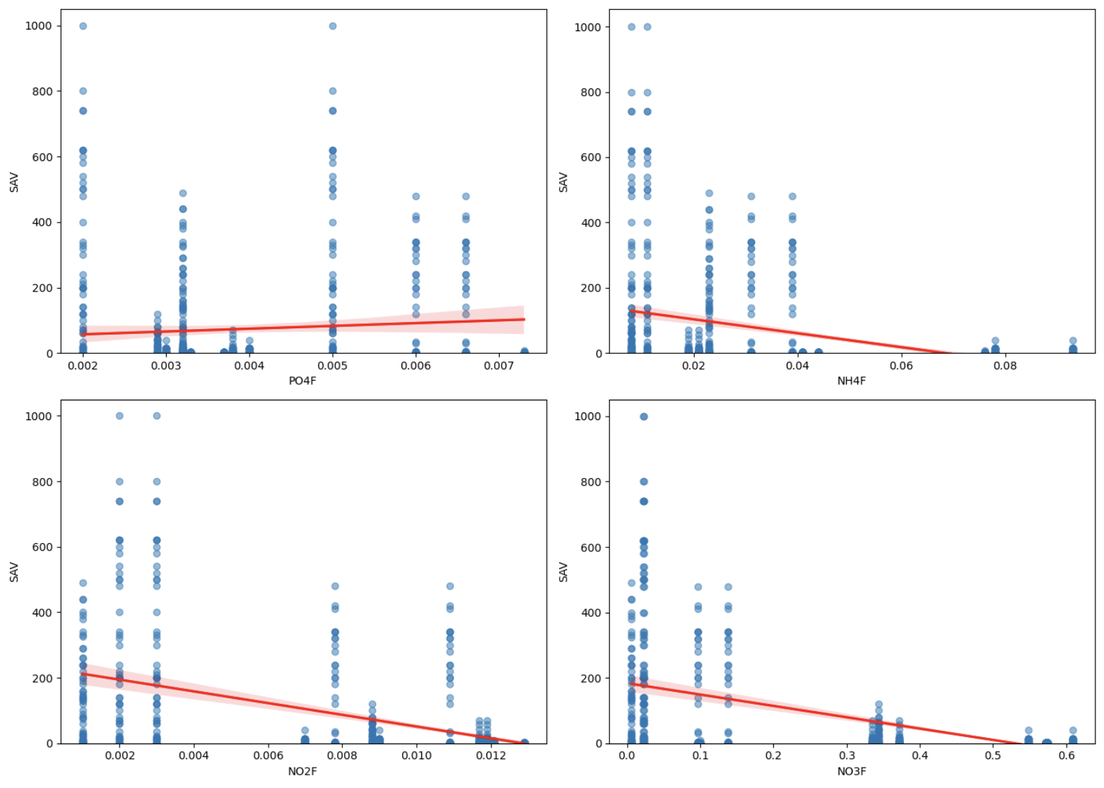

**Figure 5.1:** Linear regression comparing SAV growth with orthophosphate (PO4F), ammonium (NH4F), nitrite (NO2F), and nitrate (NO3F). Daily continuous monitoring station nutrient data (2003- 2023) was provided by the National Estuarine Research Reserve (NERR). The Y-axis portrays the volume of SAV while the X-axis shows the concentration of the different nutrients.

| **Site** | **pH** | **Nitrogen (ppm)** | **Nitrate (ppm)** | **Ammonium (ppm)** | **Phosphorus (ppm)** | **Potassium (ppm)** | **Sulfur (ppm)** | **Calcium (ppm)** | **Magnesium (ppm)** | **Sodium (ppm)** | **Iron (ppm)** | **Manganese (ppm)** | **Zinc (ppm)** | **Copper (ppm)** | **Boron (ppm)** |
| --- | --- | --- | --- | --- | --- | --- | --- | --- | --- | --- | --- | --- | --- | --- | --- |
| **Attkison Dam (Downstream 1)** | **7.18** | **1.61** | **0.51** | **1.1** | **0.34** | **3.64** | **2.68** | **26.42** | **4.26** | **7.29** | **0.47** | **0.79** | **0.01** | **0.01** | **0.04** |
| **Attkison Dam (Upstream 1)** | **6.83** | **1.61** | **0.51** | **1.1** | **7.54** | **7.66** | **6.42** | **37.04** | **16.4** | **20.97** | **121.43** | **3.66** | **0.12** | **0.01** | **0.17** |
| **Atkisson Dam (Upsream 2)** | **6.06** | **3.17** | **0.99** | **2.18** | **3.13** | **8.33** | **8.62** | **62.67** | **18.43** | **11.35** | **37.39** | **0.95** | **0.08** | **0.01** | **0.08** |
| **Atkisson Dam Downstream** | **7.18** | **1.61** | **0.51** | **1.1** | **0.34** | **3.64** | **2.68** | **26.42** | **4.26** | **7.29** | **0.47** | **0.79** | **0.01** | **0.01** | **0.04** |
| **Atkisson Dam Upstream (Average)** | **6.445** | **2.39** | **0.75** | **1.64** | **5.335** | **7.995** | **7.52** | **49.855** | **17.415** | **16.16** | **79.41** | **2.305** | **0.1** | **0.01** | **0.125** |
| **Van Bibber Dam (Upstream 1)** | **7.09** | **11.63** | **2.49** | **9.14** | **2.5** | **5.9** | **3.32** | **27.05** | **6.66** | **11.29** | **159.46** | **17.29** | **0.03** | **0.03** | **0.1** |
| **Van Bibber Dam (Upstream 2)** | **6.31** | **6.49** | **3.02** | **3.47** | **4.99** | **9.77** | **15.21** | **48.62** | **14.28** | **14.47** | **117.01** | **13.57** | **0.12** | **0.01** | **0.05** |
| **Van Bibber Dam (Downstream 1)** | **6.88** | **9.95** | **2.19** | **7.76** | **2.49** | **8.42** | **6.64** | **54.02** | **14.18** | **13.12** | **118.11** | **28.03** | **0.09** | **0.02** | **0.07** |
| **Van Bibber Dam (Downstream 2)** | **6.25** | **5.94** | **1.5** | **4.44** | **0.53** | **4.07** | **2.87** | **21.74** | **6.71** | **5.05** | **0.43** | **1.07** | **0.01** | **0** | **0.02** |
| **Van Bibber Dam Upstream (Average)** | **6.7** | **9.06** | **2.755** | **6.305** | **3.745** | **7.835** | **9.265** | **37.835** | **10.47** | **12.88** | **138.235** | **15.43** | **0.075** | **0.02** | **0.075** |
| **Van Bibber Dam Downstream (Average)** | **6.565** | **7.945** | **1.845** | **6.1** | **1.51** | **6.245** | **4.755** | **37.88** | **10.445** | **9.085** | **59.27** | **14.55** | **0.05** | **0.01** | **0.045** |
| **Otter Point Creek** | **7.03** | **8.31** | **1.32** | **7** | **1.46** | **5.75** | **10** | **25.37** | **16.64** | **15.9** | **39.11** | **3.15** | **0.11** | **0.01** | **0.1** |
| **Optimal Range** | **6.5 - 9.0** | **1.5 - 2.5** | **0 - 1** | **0 - 0.02** | **10 - 30** | **5 - 10** | **7 -16** | **93 - 314** | **4 - 18** | **0 - 20** | **0.1 - 1** | **0.1 - 0.2** | **0.01 - 0.2** | **0.03 - 0.1** | **0.1 - 0.5** |

**Table 1.1:** Table containing MySoil sediment results from the Atkisson Dam, Van Bibber Dam and Otter Point Creek sites. Optimal range as per EPA standards are also included. Red values portray measurements outside of the recommended EPA range, while green values show measurements within recommended levels.

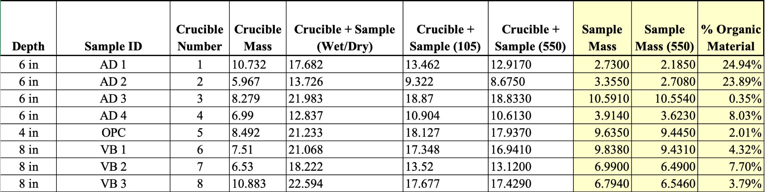

**Table 2.1:** Combustion analysis table including all measurements of mass, organic material, and crucible weight. AD 1-2 denotes the upstream samples from Atkisson Dam. AD 3-4 denotes the downstream samples from Atkisson Dam. VB 1-2 denotes the upstream samples from the Van Bibber Weir. VB 3 is the downstream sample from Van Bibber Weir.

| **Name** | **Year Valid** | **Description** | **Source** |
| --- | --- | --- | --- |
| Bush River Station Water Quality Data (2003 - 2005) | 2003 - 2005 | Water data quality including water depth, temperature, salinity, turbidity, pH, dissolved oxygen, and chlorophyll A concentrations from 2003 - 2005. YSI6600V2 data logger used to record water quality data using Eastern Standard Time. In-situ readings are taken with series 3 or 4a Hydrolab sonder. | [Maryland.gov ‘Eyes on the Bay’ DATAFLOW](https://eyesonthebay.dnr.maryland.gov/sim/Dataflow.cfm) |
| Otter Point Creek Nutrient Data (2003 - 2022) | 2003 - 2022 | Water nutrient data including nitrite, nitrate, orthophosphate, and chlorophyll A concentrations. | [NERRs Advanced Query System](https://cdmo.baruch.sc.edu/aqs/) |
| Otter Point Creek Water Quality Data (2003 - 2024) | 2003 - 2024 | Water data quality including water depth, temperature, salinity, turbidity, pH, dissolved oxygen, and chlorophyll A concentrations from 2003 - 2024. YSI6600V2 data logger used to record water quality data using Eastern Standard Time. In-situ readings are taken with series 3 or 4a Hydrolab sonder. | [NERRs Advanced Query System](https://cdmo.baruch.sc.edu/aqs/) |

**Table 3.1:** List of data sources utilized in the data analysis and GIS analysis performed in this study, including the source, description of the data as well as years in which the data is valid.

**References**

Afshan, S., Ali, S., Ameen, U. S., Farid, M., Bharwana, S. A., Hannan, F., & Ahmad, R. (2014). Effect of Different Heavy Metal Pollution on Fish. *Research Journal of Chemical and Environmental Sciences*, *2*(1), 74–79. <https://www.researchgate.net/publication/269784904_Effect_of_Different_Heavy_Metal_Pollution_on_Fish>

Ali, H., & Khan, E. (2018). Bioaccumulation of non-essential hazardous heavy metals and metalloids in freshwater fish. Risk to human health. *Environmental Chemistry Letters, 16*(3), 903–917. <https://doi.org/10.1007/s10311-018-0734-7>

Ali, M.M., & Soltan, M.E. (1996). The impact of three industrial effluents on submerged aquatic plants in the River Nile, Egypt. *Hydrobiologia, 340*, 77-83. <https://link.springer.com/article/10.1007/BF00012737>

Barko, J.W., & James, W.F. (1998). Effects of Submerged Aquatic Macrophytes on Nutrient Dynamics, Sedimentation, and Resuspension. *Ecological studies, 131*, 197-214. <https://link.springer.com/chapter/10.1007/978-1-4612-0695-8_10>

Bednarek, A. T. (2001). Undamming Rivers: A Review of the Ecological Impacts of Dam Removal. *Environmental Management*, *27*(6), 803–814. <https://doi.org/10.1007/s002670010189>

Bellmore, J. R., Pess, G. R., Duda, J. J., O’Connor, J. E., East, A. E., Foley, M. M., Wilcox, A. C., Major, J. J., Shafroth, P. B., Morley, S. A., Magirl, C. S., Anderson, C. W., Evans, J. E., Torgersen, C. E., & Craig, L. S. (2019). Conceptualizing ecological responses to dam removal: If you remove it, what’s to come? *BioScience, 69*(1), 26–39. <https://doi.org/10.1093/biosci/biy152>

Burkhead, N. M. (2012). Extinction rates in North American freshwater fishes, 1900–2010. *BioScience, 62*(9), 798–808. <https://doi.org/10.1525/bio.2012.62.9.5>

Chilton, D., Hamilton, D. P., Nagelkerken, I., Cook, P., Hipsey, M. R., Reid, R., Sheaves, M., Waltham, N. J., & Brookes, J. (2021). Environmental flow requirements of estuaries: Providing resilience to current and future climate and direct anthropogenic changes. *Frontiers in Environmental Science, 9*. <https://doi.org/10.3389/fenvs.2021.764218>

Cheng, F., & Granata, T. (2007). Sediment transport and channel adjustments associated with dam removal: Field observations. *Water Resources Research, 43*. <https://agupubs.onlinelibrary.wiley.com/doi/10.1029/2005WR004271>

Davies‐Colley, R. J., & Smith, D. G. (2001). Turbidity, suspended sediment, and water clarity: A review. *JAWRA Journal of the American Water Resources Association*, *37*(5), 1085–1101. <https://doi.org/10.1111/j.1752-1688.2001.tb03624.x>

Ellison, C., Kiesling, R., & Fallon, J. (2009). Correlating streamflow, turbidity, and suspended-sediment concentration in Minnesota’s wild rice river. Retrieved from <https://acwi.gov/sos/pubs/2ndJFIC/Contents/8B_Ellison_12_03_09_paper.pdf>

Environmental Protection Agency*.* (2021)*. Nutrient Criteria Technical Guidance Manual Wetlands. (2008). Retrieved from* [*https://www.epa.gov/sites/default/files/2018-10/documents/nutrient-criteria-manual-wetlands.pdf*](https://www.epa.gov/sites/default/files/2018-10/documents/nutrient-criteria-manual-wetlands.pdf)

Foley, M.M., Duda, J.J., Beirne, M.M., Paradis, R., Ritchie, A.C., & Warrick, J.A. (2015). Rapid water quality change in the Elwha River estuary complex during dam removal. *Limnology and Oceanography, 60*. <https://aslopubs.onlinelibrary.wiley.com/doi/10.1002/lno.10129>

Foley, M.M., Warrick, J.A., Ritchie, A.C., Stevens, A.W., Shafroth, P.B., Duda, J.J., Beirne, M.M., Paradis, R., Gelfenbaum, G.R., McCoy, R.E., & Cubley, E.S. (2017). Coastal habitat and biological community response to dam removal on the Elwha River. *Ecological Monographs, 87*, 552-577. <https://esajournals.onlinelibrary.wiley.com/doi/10.1002/ecm.1268>

Fonseca, M. S., Kenworthy, W. J., & Thayer, G. W. (1998). *Guidelines for the conservation and restoration of seagrasses in the United States and adjacent waters*. NOAA Institutional Repository. <https://repository.library.noaa.gov/view/noaa/1672>

Huang, C. S., Legett, H. D., Plough, L. V., Aguilar, R., Fitzgerald, C., Gregory, B., Heggie, K., Lee, B., Richie, K. D., Harbold, W., & Ogburn, M. B. (2023). Early detection and recovery of river herring spawning habitat use in response to a mainstem dam removal. *PLOS ONE*, *18*(5). <https://doi.org/10.1371/journal.pone.0284561>

IFAS. (2024). *Center for aquatic and invasive plants: University of Florida, IFAS*. Center for Aquatic and Invasive Plants | University of Florida, IFAS. <https://plants.ifas.ufl.edu/plant-directory/hydrilla-verticillata/>

Isbell, F., Calcagno, V., Hector, A., Connolly, J., Harpole, W. S., Reich, P. B., … Loreau, M. (2011). High plant diversity is needed to maintain ecosystem services. *Nature, 477*(7363), 199–202. <https://doi.org/10.1038/nature10282>

Lisius, G.L., Snyder, N.P., & Collins, M.J. (2018). Vegetation community response to hydrologic and geomorphic changes following dam removal. *River Research and Applications, 34*, 317 - 327. <https://onlinelibrary.wiley.com/doi/10.1002/rra.3261>

Miththapala, S. (2008). *Seagrasses and Sand Dunes*. IUCN. <https://portals.iucn.org/library/efiles/documents/CES-003.pdf>

Morris, K., Bailey, P.C., Boon, P.I., & Hughes, L. (2003). Alternative stable states in the aquatic vegetation of shallow urban lakes. II. Catastrophic loss of aquatic plants consequent to nutrient enrichment. *Marine and Freshwater Research, 54*, 201-215. <https://www.publish.csiro.au/mf/MF02003>

Native Wild Rice Coalition. Ecological Importance. (2024). Retrieved February 23, 2024, from Native Wild Rice Coalition website: <http://www.nativewildricecoalition.com/ecological-importance.html>

Nedwell, D. B., Jickells, T. D., Trimmer, M., & Sanders, R. (1999). Nutrients in Estuaries. In *Advances in Ecological Research: Estuaries* (Vol. 29, pp. 43–84). essay, Academic Press. Retrieved 2024, from <https://books.google.com/books?hl=en&lr=&id=pGL-OsGyRJUC&oi=fnd&pg=PA43&dq=effects+of+excess+nutrients+on+estuarine+ecosystems+from+dam+removals&ots=EXPa-y31aM&sig=df_h8p1_5ojSBIMpVul6ZsSm9tg#v=onepage&q&f=false>.

NOAA Fisheries. (2022, September 20). *Submerged aquatic vegetation: A habitat worth sav-ing*. <https://www.fisheries.noaa.gov/feature-story/submerged-aquatic-vegetation-habitat-worth-sav-ing#:~:text=The%20term%20used%20for%20a,submerged%20aquatic%20vegetation%20(SAV)>

Ogburn, M. B., Plough, L. V., Bangley, C. W., Fitzgerald, C. L., Hannam, M. P., Lee, B., Marafino, G., Richie, K. D., Williams, M. R., & Weller, D. E. (2022). Environmental DNA reveals anadromous river herring habitat use and recolonization after restoration of aquatic connectivity. *Environmental DNA*, *5*(1), 25–37. <https://doi.org/10.1002/edn3.348>

The Otter Point Creek Alliance Vision. (2024, February 23). *About*. Otter Point Creek Alliance. <https://otterpointcreek.org/about/>

Palinkas, C. M., Testa, J. M., Cornwell, J. C., Li, M., & Sanford, L. P. (2019). Influences of a river dam on delivery and fate of sediments and particulate nutrients to the adjacent estuary: Case study of Conowingo Dam and Chesapeake Bay. *Estuaries and Coasts, 42*(8), 2072–2095. <https://doi.org/10.1007/s>

Parsons, A. J., Cooper, J., & Wainwright, J. (2015). What is suspended sediment? *Earth Surface Processes and Landforms*, *40*(10), 1417–1420. <https://doi.org/10.1002/esp.3730>

Preisendorfer, R. W. (1986). *Eyeball optics of natural waters: Secchi Disk Science*. NOAA. <https://www.pmel.noaa.gov/pubs/PDF/prei827/prei827.pdf>

Rattner, B. A., Wazniak, C. E., Lankton, J. S., McGowan, P. C., Drovetski, S. V., & Egerton, T. A. (2022). Review of harmful algal bloom effects on birds with implications for avian wildlife in the Chesapeake Bay Region. *Harmful Algae*, *120*, 102319. <https://doi.org/10.1016/j.hal.2022.102319>

Rozas, L. P., & Odum, W. E. (1988). Occupation of submerged aquatic vegetation by fishes: testing the roles of food and refuge. *Oecologia, 77*(1), 101–106. <https://doi.org/10.1007/bf00380932>

Shields, E. C., Moore, K. A., & Parrish, D. B. (2011). Influences of salinity and light availability on abundance and distribution of tidal freshwater and oligohaline submersed aquatic vegetation. *Estuaries and Coasts*, *35*(2), 515–526. <https://doi.org/10.1007/s12237-011-9460-0>

U.S. Army Garrison Aberdeen Proving Ground Directorate of Public Works. (2022). *Removal of Atkisson Dam and Van Bibber Weir at U.S. Army Garrison Aberdeen Proving Ground* (Draft Environmental Assessment No. XXXX). Maryland: Aberdeen Proving Ground.

Vanni, M. J., Bowling, A. M., Dickman, E. M., R. Scott Hale, Higgins, K. A., Horgan, M. J., … Stein, R. A. (2006). Nutrient cycling by fish supports relatively more primary production as lake productivity increases. Ecology, 87(7), 1696–1709. [https://doi.org/10.1890/0012-9658(2006)87[1696:ncbfsr]2.0.co;2](https://doi.org/10.1890/0012-9658(2006)87%5B1696:ncbfsr%5D2.0.co;2)

Wang, Q., Yuan, X., Liu, H., Zhang, Y.Z., Cheng, Z.S., & Li, B. (2012). EFFECT OF LONG-TERM WINTER FLOODING ON THE VASCULAR FLORA IN THE DRAWDOWN AREA OF THE THREE GEORGES RESERVOIR, CHINA. *Polish Journal of Ecology, 60*, 95-106. <https://miiz.waw.pl/pliki/article/ar60_1_07.pdf>

Yu, H., Qi, W., Liu, C., Yang, L., Wang, L., Tian Lv, & Peng, J. (2019). Different Stages of Aquatic Vegetation Succession Driven by Environmental Disturbance in the Last 38 Years. Water, 11(7), 1412–1412. <https://doi.org/10.3390/w11071412>

Zhang, Q., Blomquist, J. D., Fanelli, R. M., Keisman, J. L., Moyer, D. L., & Langland, M. J. (2023). Progress in reducing nutrient and sediment loads to Chesapeake Bay: Three decades of monitoring data and implications for restoring complex ecosystems. *WIREs Water*, *10*(5). <https://doi.org/10.1002/wat2.1671>

Zhang, Y., Jeppesen, E., Liu, X., Qin, B., Shi, K., Zhou, Y., … Deng, J. (2017). Global loss of aquatic vegetation in lakes. *Earth-Science Reviews, 173*, 259–265. <https://doi.org/10.1016/j.earscirev.2017.08.013>